3.36: Repeated use of Eq. (3.33) gives a) 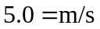 to the right, b) 16.0 m/s to the left, and c) 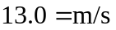 to the left.

